Exercise 25: HTTPS and Cors

Objective
In this exercise, you’ll learn about handling Cross-Origin Resource Sharing (CORS) effectively when dealing with different ports in development and production environments is a common task in web development. Browsers enforce the same-origin policy for security reasons, which restricts how resources from one origin can interact with resources from another origin. An "origin" is defined by the scheme (protocol), host (domain), and port of the URL. Therefore, even different ports on the same domain are considered different origins.

Exercise
- Copy node-https app and rename https-cors
- Add cors.js in routes folder
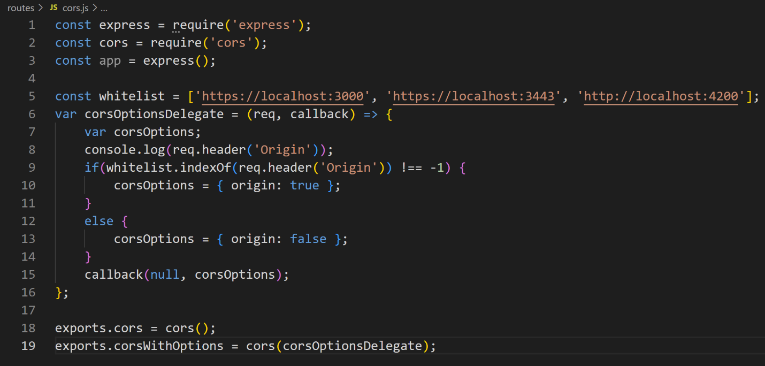
- Change code in articleRouter.js
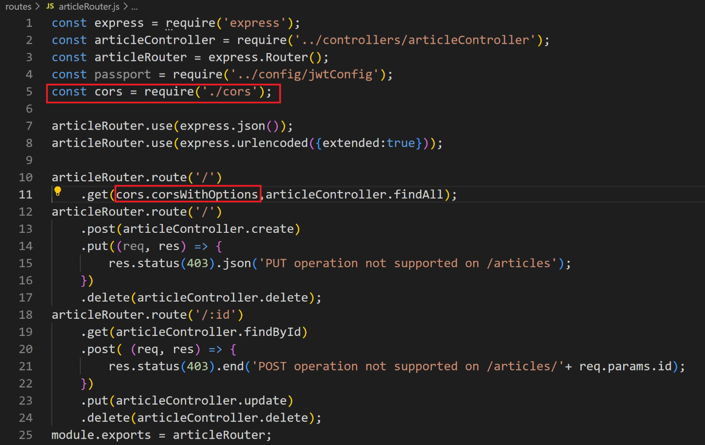

- Test with Postman
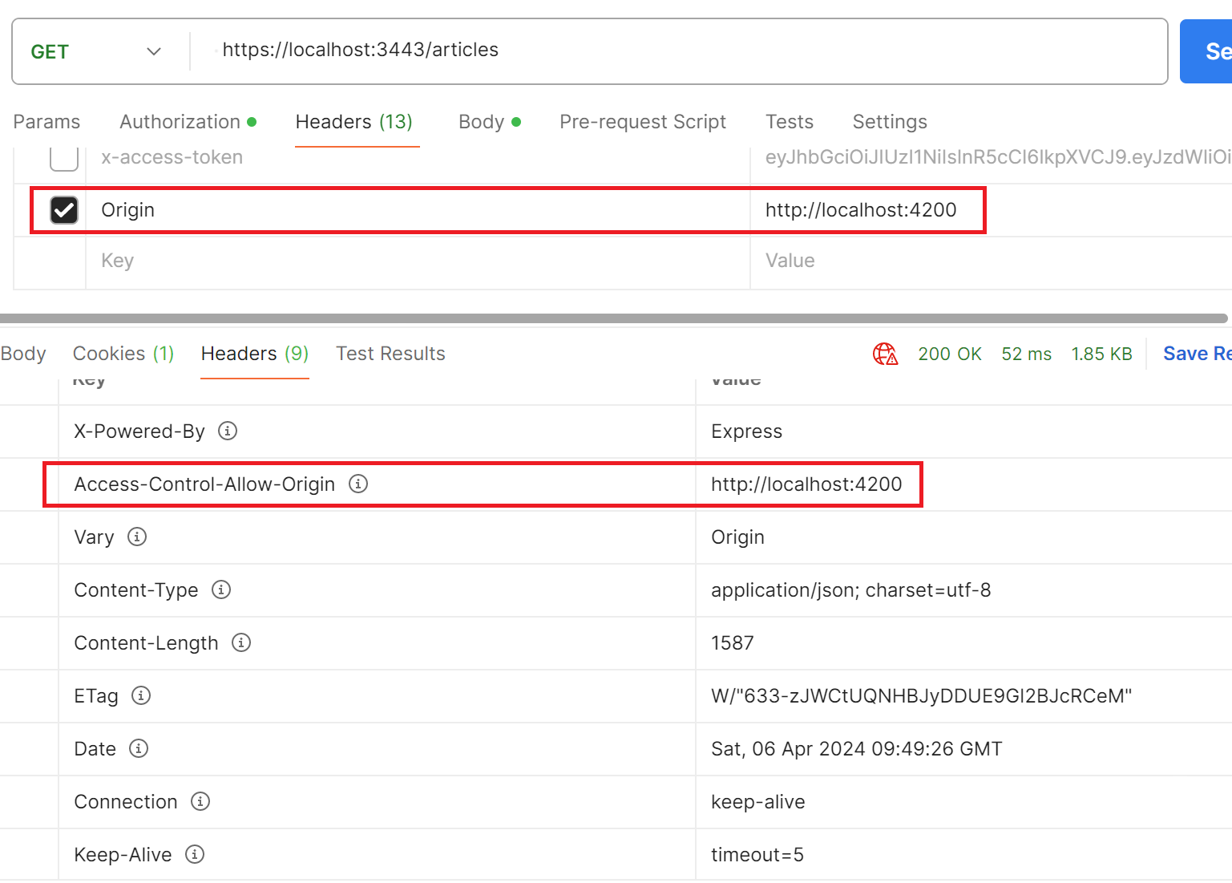

Conclusion
After doing this exercise, you can ensure that your Node.js applications handle CORS effectively, maintaining both functionality and security. Remember, the goal of CORS is not to prevent your application from receiving requests but to ensure that these requests are made in a controlled and secure manner.

